Literature Review Summaries

Topic: Innovation, Market Structure and Firm Size
Author: Zoltan J. Acs and David B. Audretsch
Web URL: http://www.jstor.org/stable/1935950
Journal: Review of Economics and Statistics & The MIT Press
Publish Date: November 1987

Research Questions/Aims:

- Testing the hypothesis that the relative innovative advantage between large and small firms is determined by the market concentration, extent of entry barriers, the composition of firm size within the industry and also the overall importance of innovative activity.

- Using data released from the US Small Business Administration to apply a direct measure of innovation for large and small firms which are categorized based on Standard Industrial Classification (SIC) codes.

Data and Methods:

- The innovation measure in this research is just the total number of innovations in each SIC industry in 1982.

- The US Small Business Administration identified innovations in 1982 which appeared in over 100 trade journals spanning every manufacturing industry.

- To test the hypothesis that the difference between the large and small firms innovation rates is related to the extent of imperfect market competition, we estimate a regression model which takes into account large and small firm innovation rates as well as measure of growth, concentration ratio, advertising to sales ratio and human capital.

Main Findings:

- The empirical results suggest that the relative innovative advantage of large and small firms is determined by the extent to which a market is characterized by imperfect competition.

- Evidence suggests that the relative innovative advantages between large and small firms can be different for different manufacturing industries even though the mean manufacturing innovation rate of small firms exceeds that of large firms.

‘

Topic: Innovation in Large and Small Firms: An Empirical Analysis
Author: Zoltan J. Acs and David B. Audretsch
Web URL: http://www.jstor.org/stable/1811167
Journal: American Economic Review
Publish Date: September 1988

Research Questions/Aims:

- The authors created a model which suggested that innovative output is influenced by R&D and market structure characteristics.

- Main purpose of the paper is to find new measures examining technical change by introducing a more direct measure of innovative activity to determine its properties and illustrate its use with a empirical model.

- The two hypotheses being tested in this research are:
- The degree to which R&D expenditures produce innovative output is conditioned by the market structure characteristics.
- Small and large firms innovative activity respond to distinct technological and economic regimes

Data and Methods:

- Like the previous research summary, this project measures the innovative activity is the number of innovations in each four digit SIC industry in 1982 which were identified by the US Small Business Administration.
- The Small Business Administration classified each of the 4,938 innovations to one of the following levels of significance:
- The innovation established an entirely new category of product.
- The innovation is the first of its type on the market in a product category already in existence.
- The innovation represents a significant improvement in existing technology.
- The innovation is a modest improvement designed to update an existing product.

- A major criterion for shortlisting data sources that should be taken into account is that trade journals report relatively fewer processes, services and management innovations and tend to focus mostly on product innovations which creates a large bias underestimating the number of innovations emanating from large firms since large firms tend to produce more process innovations than smaller ones.
- The table below shows the number of innovations and the relative innovative activity of large and small firms in the most innovative industries in 1982.

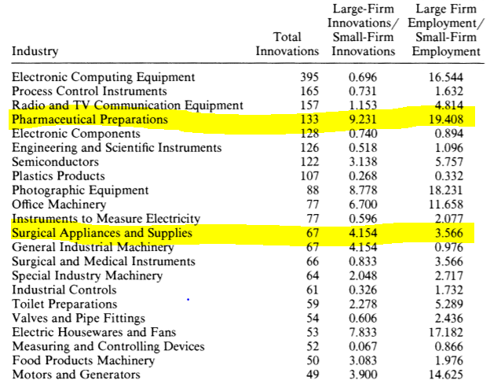

- The next table would provide a detailed comparison between company R&D expenditure (input measure) and total number of innovations and total number of patented innovations between June 1976 and March 1977 (output measures)

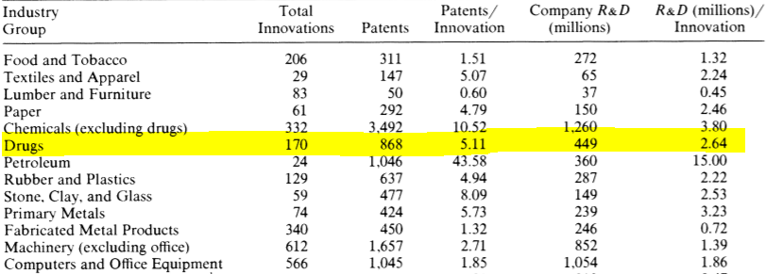

Main Findings:

- The total number of innovations is closely related to R&D expenditures and patented inventions and the exact relationship between R&D and innovations is different from that between R&D and patents.

- Rather than considering what determines the extent of innovative activity in small firms, small firms innovative activity is examined relative to that in the entire industry,

Topic: Entrepreneurship and Innovation
Author: Zoltan J. Acs and David B. Audretsch
Journal: Max Planck Institute of Economics
Publish Date: May 2005

Research Questions/Aims:

- The paper aims to understand the role that entrepreneurship and small firms play with respect to technological change and innovation. Content is divided into three sections as follows:
- Issues arising when trying to measure innovation activity.
- Relationship between innovative activity and firm size.
- Impact of external industry environment onechnological change.

Data and Methods:

- The first attempt to directly measure innovative output by Gellman Research Associates involved a compiled database by identifying 500 major innovations in the US market between 1953 and 1973.
- Their second attempt involved work with the US Small Business Administration wherein Gellman compiled a total of 635 innovations out of which 590 were selected from a list of fourteen industry specific trade journals.
- The US Small Business Administration maintains a Small Business Administration’s Innovation Database (SBIDB) which contains a list of 8,074 innovations commercially introduced in 1982. A private firm compiled the data and performed quality control analysis by examining over a hundred science based trade journals spanning every industry in manufacturing. An innovation database was compiled based on SIC codes and this was further analyzed to understand the relationship between firm size and technical change.

Main Findings:

- Entrepreneurial small firms make a large contribution to the innovation activities and technological changes in the US.
- The SBIDB database revealed similar patterns with respect to the distribution of innovations among large and small manufacturing industries.

Topic: Innovation in the pharmaceutical industry: New estimates of R&D costs
Author: Joseph DeMasi, Henry Gabowski, Ronald Hansen
Journal: Journal of Health Economics
Publish Date: 12th February 2016

Research Questions/ Aim:

- It provides an assessment of the value of the resources expended by the industry to discover and develop new drugs and biologics.
- Developing estimates of the average pre tax costs of new drug development and compare them to estimates covering prior periods.
- Discussing literature on pharmaceutical industries R&D costs since 2003.
- Outlining the standard paradigm for the drug development process and understanding the cost of pharmaceutical innovation.

Data and Methods:

- Ten multinational pharmaceutical firms of varying sizes provided data through a confidential survey of their new drug and biologics R&D costs. Even though the names for these firms aren’t mentioned, 5 of the survey firms are top 10 companies, 7 are top 25 companies and the remaining 3 are outside the top 25. (Pharmaceutical Executive, 2007)
- Collected data from the from the cost survey participants on their aggregate annual R&D expenditure from 1990-2010.
- The project dataset included 106 investigational compounds each of which are referred to as a new drug.
- The main criterion while selecting investigational compounds was that the compounds were self originated and were first tested by humans between 1995 and 2007. This criterion led to the discovery of 1442 investigational compounds out of which 103 (7.1%) had been approved for marketing

Main Findings:

- The clinical success rates are substantially lower for the studies focused on most recent periods.
- Average R&D cost estimates are higher for studies focused during more recent periods suggesting a large growth in real R&D costs.
- 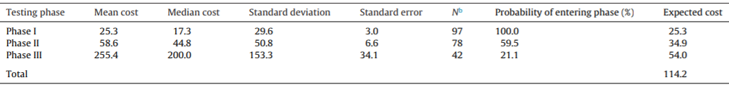

- From 2000-2010, pre-approvals out of pockets cost experienced a 166% growth while the capitalized cost estimate is 145% higher.

Topic: Customer relationship management in retailing: A content analysis of retail trade journals
Author: Joal Anderson, Laura Jolly, Ann Fairhurst
Web URL: https://pdfs.semanticscholar.org/678a/9419a680807f41a53c520b6b3470f6babd1b.pdf
Journal: Journal of Retailing and Consumer Services
Publish Year: 2007

Research Question/ Aims

- To understand how retailers use business intelligence and data mining techniques to implement customer relationship management (CRM).
- The main objectives of this project are:
- Identify organization and infrastructure requirements for CRM effectiveness.
- Identify CRM objectives, goals and strategies of retail companies.
- Identify data mining tools utilized by retailers to perform CRM.

Data and Methods

- For this study, content analysis of industry trade journals was used. It involved analyzing large text based database to identify the frequency of keywords and discern patterns within the data and articles from four retail trade publications analyzed over a five year period.
- Trade journal discovery focused on the retail industry and trade/management publications to understand trends and tactics related to CRM.
- An initial list of 34 publications were identified by an environmental scan. Environmental scanning is the process of gathering information about events and their relationship with an organization’s internal and external environments.
- Content Stores, Chain Store Age, Harvard Business Review and Retail Forward were identified as the most prominent publications that address CRM from a retail management perspective.
- Articles from the selected publications were included from analysis and stored as text in a QDA miner which is a qualitative analysis tool used for linking descriptive variables to each article.

Main Findings

- Organizational and infrastructure requirements for CRM effectiveness:
- Data structure requirement was the most frequently mentioned issue (54% of total mentions)
- Retailers cited the need for data integration at all levels.

- CRM goals and objectives:
- Results showed that retailers using CRM strategies helped improve market effectiveness with initiatives such as personalization and the use of real time promotional efforts.

- Data mining tools:
- The most commonly mentioned tools were market basket and product affinity analysis.
- Analyzing customer profitability ratings such as customer lifetime value and click stream analysis of online retail sites figured prominently.

Topic: Comparison of SCImago Journal Rank indicator with Journal Impact Factor
Author: Mathew E. Fallagas and Vasilios D. Kouranos
Web URL: https://pdfs.semanticscholar.org/6105/08a997c6f822e73709a24794e53e40aa236f.pdf
Journal: The FASEB Journal, Life Sciences Forum
Publish Date: August 2008

Research Questions/Aims

- The article aims to compare the SCImago Journal Rank indicator with the Journal Impact Factor. The Journal Impact Factor (JIF) has been used since 1955 and has been used since then as an index of quality of scientific journal and is based on citation analysis. The increasing use of the SJR requires us to understand the benefits and limitations of both indicators.

Data & Methods

- The top 100 JIFs were collected and their corresponding SJR rankings were retrieved.
This JIF method raised questions regarding lack of assessment of qualities citations, inclusions of self-citations and assessments of mainly English articles (Table 1).

Table 1
- The SJR indicator takes into account the different weights to citations depending on the prestige of the citing journal without the influence of self-citations. Prestige is estimated with the application of the PageRank algorithm in the network of the journals.

- The main characteristics of the evolution of scientific journals by journal citation reports and by SCImago journal ranks were collected.

Results

- Table 2 shows the first 20 ranked journals of all categories with each one of the compared indices and their corresponding rank using the other index. Out of the 20 journals, 13 retained a position in the top 20 journals with the use of the SJR Indicator.

Table 2

- Among the top 100 journals in the 2006 JIF ranking order, the median absolute change in their ranking position with the use of the SJR indicator is 32 (1st quartile: 12; 3rd quartile: 75). Correspondingly, the top 100 journals with the current SJR indicator, the median absolute change in their ranking position with the use of the journal IF is 29 (1st quartile: 10.5; 3rd quartile: 65.5).

- The journals with the greatest relative increase in their ranking order in the SJR indicator compared to the JIF were the journals Immunity, Molecular Cell, Annual Review of Cell and Developmental Biology, Cell, and Current Opinion in Cell Biology

